Making Maths: Equilateral Triangle Folding
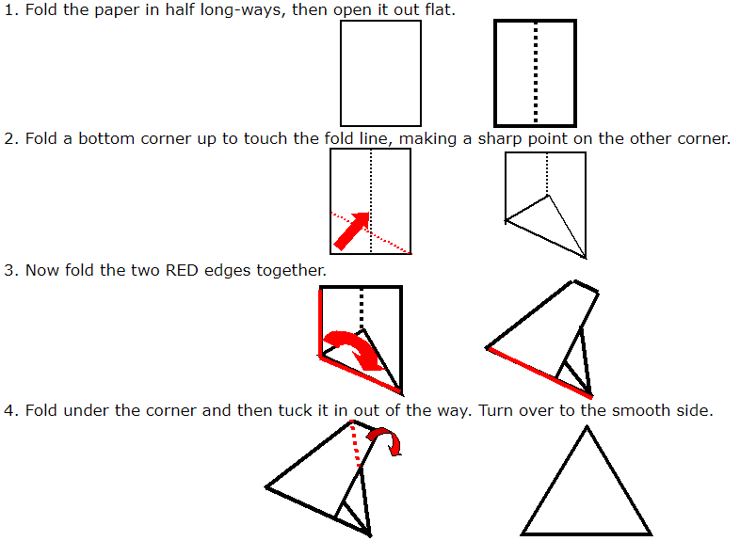
Here's an easy way to fold any rectangle of paper into a triangle with three sides the same length.

Now why not make some more from coloured paper and create some designs.
