Miss Dunn’s Cookie Recipe

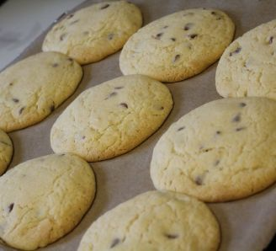
Ingredients
- 125g butter, softened
- 100g light brown soft sugar
- 125g caster sugar
- 1 egg, lightly beaten
- 1 tsp vanilla extract
- 225g self-raising flour
- ½ tsp salt
- 200g chocolate chips

Method
  - Preheat the oven to 180°C, gas mark 4
  - Cream butter and sugars, once creamed, combine in the egg and vanilla.
  - Sift in the flour and salt, then the chocolate chips.
  - Roll into walnut size balls, for a more homemade look, or roll into a long, thick sausage shape and slice to make neater looking cookies. *TIP – They do expand! Spread them out well on the baking tray!*
  - Place on ungreased baking paper. If you want to have the real Millies experience then bake for just 7 minutes, till the cookies are just setting - the cookies will be really doughy and delicious. Otherwise cook for 10 minutes until just golden round the edges.
  - Take out of the oven and leave to harden for a minute before transferring to a wire cooling rack. These are great warm, and they also store well, if they don't all get eaten straight away!
https://www.bbcgoodfood.com/user/23650/recipe/millies-cookies-recipe

