Year 6 Home Learning Tasks
English | Reading Challenge:  Using the book recommendation sheet, challenge yourself to read one book every week.  Record the books that you have read in your reading diary and note your thoughts and opinions of each text.  Spelling Shed:  www.spellingshed.com  This is a spelling APP which can be downloaded on your iPhone, iPad or iPod touch. You can access Year 5 and 6 key words and can learn them through games and puzzles.  Instructional Writing:  Create an instructional piece of writing of your own choice. This writing could link to a DT project you have been doing at home or it could link to a recipe.
Maths | - 15 minutes daily practice on ‘TT Rockstars’.  Useful maths sites:  - www.topmarks.co.uk  - www.primarygames.com  - www.mathsframe.co.uk  - www.nrich.maths.org
Science | Humans: The Circulatory System  - Create your own ‘Lifestyle Chart’… Worksheet available or you can make your own.  - Describe how you keep a healthy lifestyle.
Geography | Ordnance Survey Maps  Learn the eight points of a compass, 6 figure grid reference and some basic symbols and keys on an ordnance survey map.  - Record some symbols and note their meaning.  - Produce a map of the local area using OS symbols
History | WW2 and Britain since 1950s  - Research the events of WW2 and compile a timeline.
Art and Design | WW2 Artists  Research LS Lowry and produce a sketch/painting in a similar style.  https://www.bbc.co.uk/bitesize/clips/z3gkq6f  The PowerPoint and clip will tell you about Lowry’s work and life.
Design Technology | 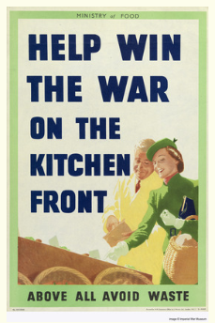  Cooking – WW2  Research wartime recipes and describe the term ‘rationing’.  Ask an adult to help you make a wartime ‘dish’.  Please take a photograph and send it to me on Seesaw.
PE | Design a 30 minute fitness activity and explain how to do it.

