Year 6 Home Learning – WB 20th April 2020
Maths | Focus: Angles  Videos are available online to introduce each task: www.whiterosemaths.com/homelearning/year-6/  The answers are online too so that you can check your work.  KS2 Questions based on angles.  Again, use the answer sheets to mark and edit.  Nrich Problem Solving Challenges  Please record your calculations.  Times Table Grids  Complete one grid each day and record your speed. Try and beat your time each day.
English | Spelling: Silent Letters  - PPT-Introduction  - Complete activity sheets  - Learn the spelling list – remember to ask an adult to test you!  SPAG: Prepositions  - PPT – Introduction and tasks  - Create an information page all about prepositions. Remember your page needs a title, explanations and examples.  Reading  Read the next book in ‘The Spiderwick Chronicles’ which is called ‘The Seeing Stone’. I don’t suggest you print the document out…Only read it if you can access it on a device. Following this, answer the questions on the following page.  If you can’t access this text, please read a fiction book over the course of the week.  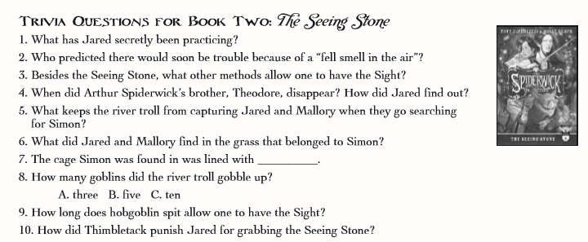  Writing  - Using the planning sheet, create a biography of a famous person of your choice.  - Check that you understand what should be included in your biography by using the key features worksheet.  - Remember: your biography should be formal and be one or two sides of your home learning book. You will need to plan, draft and redraft this piece of work.

