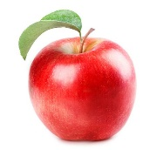**Fruits I Love** 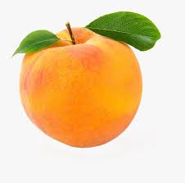

|  |  |
| --- | --- |
|  | **Write and draw your top 10 in order!** |
| **1** |  |
| **2** |  |
| **3** |  |
| **4** |  |
| **5** |  |
| **6** |  |
| **7** |  |
| **8** |  |
| **9** |  |
| **10** |  |