Informal | Formal
Go up | Increase
Go down | Decrease
Set up | Establish
Find out | Discover
Bring about | Cause
Find out | Discover, ascertain
Think about | Consider
Get | Obtain
Seem | Appear
Keep | Retain
Anyways | Nevertheless
Plus/also | Moreover/furthermore
So | Therefore
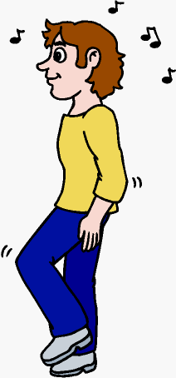  To sum up | In conclusion
Lots of / a lot of | Much, many
Tons of, heaps of | Large quantities of, a number of
Totally | Completely
Kids | Children
Bad | Negative
Good | Positive
Really big | Considerable

