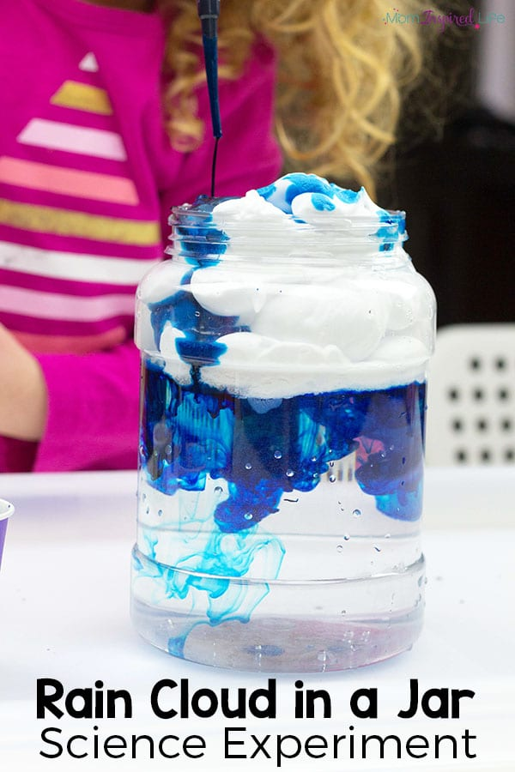

In a nutshell: Explaining that rain is not magic can be tricky – even for adults. Explaining that clouds are actually tiny droplets of moisture rather than solid, puffy, cushions can be even more challenging. Demonstrate how scientific nature can be with this cloud in a jar EYFS science experiment.
What you need:
- A jar of water
- Blue food colouring
- Shaving foam
- A medicine dropper or pipette
How you do it: Using a glass of water to demonstrate the proverbial “sky”, create a cloud to hover at the top by using shaving foam. Now, use a medicine dropper or a pipette to drop little droplets of food colouring into the cloud. Eventually, the food colouring will seep through the cloud to demonstrate rain.

