Matching Fractions

- Play ‘pairs’ or devise a game of your own using a point system.
- The cards are on an additional worksheet.
- https://nrich.maths.org/8283/note If you follow the link, you can play the game interactively.

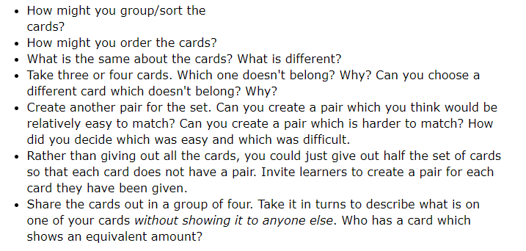
Key Questions:

