British Values: 4th – 10th May 2020
Individual Liberty
There are many types of toys for us to play with, some of them we will love, others not as much. We are all different and can decide for ourselves which we prefer! This week picture news looks at toy crazes over time. The headline for this week is ‘Move Over, Unicorns. Llamas Rule the Toy Business Now’.
Please read the news story by following the link below:
https://www.nytimes.com/2020/04/14/parenting/llamas-hot-toys.html
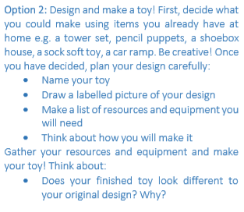
Follow-up tasks to complete:
