Year 6 Home Learning Tasks – Wider Curriculum
English | Reading Challenge:  Using the book recommendation sheet, challenge yourself to read one book every week.  Record the books that you have read in your reading diary and note your thoughts and opinions of each text.  Spelling Shed:  www.spellingshed.com  This is a spelling APP which can be downloaded on your iPhone, iPad or iPod touch. You can access Year 5 and 6 key words and can learn them through games and puzzles.  Instructional Writing:  Create an instructional piece of writing of your own choice. This writing could link to a DT project you have been doing at home or it could link to a recipe.
Maths | Useful maths sites:  - www.topmarks.co.uk  - www.primarygames.com  - www.mathsframe.co.uk  - www.nrich.maths.org
Science | Humans: The Circulatory System  - Create your own ‘Lifestyle Chart’… Worksheet available or you can make your own.  - Describe how you keep a healthy lifestyle.  ----------------------------------------------------------------  Investigation: Make a heart – a model of one of the chambers.  - Watch the following clip about the heart and how it works:  https://www.bbc.co.uk/bitesize/clips/zncg9j6  - Fill a jar half full of water.  - Cut the neck of the balloon off at the part where it starts to widen into a balloon.  - Stretch the balloon over the opening of the jar, pulling it down as tightly as you can.  - Carefully use the tip of a skewer to poke two holes in the surface of the balloon. Make them about 2 centimetres apart from each other and near opposite edges of the jar.  - Stick the long part of a straw into each hole. The straws should fit securely in the holes so no air can get through around the straws.  - Slide the uncut end of the balloon neck onto one of the straws and tape it around the straw.  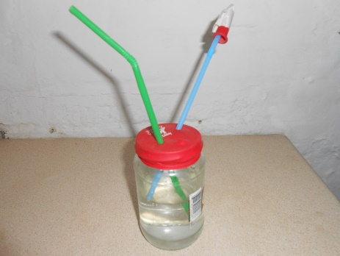  - Set your pump in a washing up bowl to catch the pumped water. Bend the straws downward. Gently press in the centre of the stretched balloon and watch what happens to the water in the jar.  This is a simple pump that moves water from the jar through the straws and into the washing up bowl. The cut end of the balloon worked as a valve to stop the water from going back down the straw. Your heart pumps blood out into your body through your arteries in a similar way.  Human hearts have four separate chambers inside. This pump shows how one chamber and its valve works. A valve is used to keep blood that has been pumped from one chamber to another from flowing back into the chamber it came from. Try taking the balloon valve off of the straw and pump water again. You likely saw that water still came out of the straw, but without the valve, there was nothing to keep some water from going back down the straw. In order to keep blood moving through your heart and into your body, your heart needs valves to separate its chambers.  Remember: if you complete this task, share a photograph of your investigation on Seesaw!  Investigation:  - What happens to the rate at which our hearts beat when we perform different exercises?  See worksheet.
RE | - Learn all about how and why Muslims participate in the month of Ramadan and how they celebrate at the end of the month with Eid ul-Fitr. Follow the link below:  https://www.bbc.co.uk/bitesize/articles/zdgrcqt
Geography | Ordnance Survey Maps  Learn the eight points of a compass, 6 figure grid reference and some basic symbols and keys on an ordnance survey map.  - Record some symbols and note their meaning.  - Produce a map of the local area using OS symbols
History | WW2 and Britain since 1950s  - Research the events of WW2 and compile a timeline.  ----------------------------------------------------------  WB 4th May:  - It is the 75th Anniversary of VE Day on Friday and there are lots of History challenges and fun tasks (including a great Dunnington School picture quiz!) to complete on the dedicated page of the school website. http://www.dunningtonprimary.co.uk/ve-day-commemoration-friday-8th-may-2020  - Complete the reading comprehension: VE Day
Art and Design | WW2 Artists  - Research LS Lowry and produce a sketch/painting in a similar style.  https://www.bbc.co.uk/bitesize/clips/z3gkq6f  The PowerPoint and clip will tell you about  Lowry’s work and life.  ----------------------------------------------------------  - Al’s Wall Competition  http://www.dunningtonprimary.co.uk/wp-content/uploads/2020/05/Paint-Als-Wall-Competition-1.pdf
Design Technology | 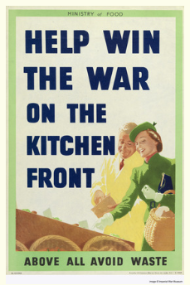  Cooking – WW2  Research wartime recipes and describe the term ‘rationing’.  Ask an adult to help you make a wartime ‘dish’.  Please take a photograph and send it to me on Seesaw.
PE | - Design a 30 minute fitness activity and explain how to do it.  -----------------------------------------------------------  - North Yorkshire Sport Virtual Challenges are activities you can do at home and compete against other children from the county of North Yorkshire. Follow the link and have a try! http://www.dunningtonprimary.co.uk/north-yorkshire-sport-virtual-challenges
Computing | Algorithms and debugging  Follow the link to complete the lesson:  - https://www.bbc.co.uk/bitesize/articles/zhdr47h

