Make a zip wire for your toys!
Which toy goes the quickest?
Why?
WHAT YOU NEED TO MAKE A TOY ZIP LINE
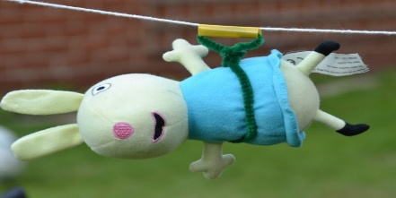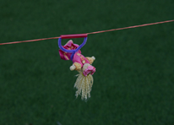
Teddies or small play figures
String, wire or wool
Pipe cleaners and straws
Timer
INSTRUCTIONS
- Think of any science variables-Type of zip wire, incline of zip wire, weight of toy, type of harness
- To test one variable, all other variables must remain constant. eg to test whether the weight of the toy makes a difference. The type of wire, incline and harness must stay exactly the same.
- Set up your zip wire and construct your harness.
- Test each toy and time how long each one takes to travel down the zip wire
- Which toy moved the quickest? What is the reason for this?

