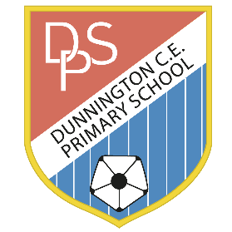
KS1 Enrichment Activities
Topic: ‘Tell me Your Tale’

1. Choose at least one homework activity from each section.
2. Share your ideas with an adult and ask for some help if you need it.
3. Make sure your work is of the highest quality you can produce (e.g. written, photograph, artwork).
4. Post a photo or video of your homework onto Seesaw for your class teacher to see. (If you can’t access Seesaw please email your child’s teacher who will pass on the account details. Thank you!)

Activities I have chosen | Homework Activity Choices
Practice your number bonds to 10 and 20 by playing the Hit the Button Games ‘Make 10’ or ‘Make 20’:
https://www.topmarks.co.uk/maths-games/hit-the-button
 | Get someone in your family to say a number between 1 and 30, can you tell them 1 more and 1 less? 10 more, 10 less? Can you write out some to share with the class?
Year 1: Practise counting backwards! Can you go back from 20, 30, 40 or even 110?! Post your video on Seesaw to really impress me.
Year 2: Go to Gig Mode on Times Table Rock Stars and see how you get on.
 | On Seesaw have a go at reading out your favourite Traditional Tale. You could have a go at acting out some of the parts. Have fun with it.
 | Create an adjective mind-map for your favourite fairy-tale character. Why note draw or paint them in the middle and write lots of adjectives about them around it.
 | Write the instructions for an Autumnal potion! You might want to include seasonal things like conkers, pumpkins, dried leaves or even fireworks. Don’t forget to decide what it does! Will it turn you into a monster or make it summer again? You decided!
 | Lots of fairy-tale characters live in castles. Design and build your own fairy-tale castle out of recycling.
 | Run, run as fast as you can, just like the Gingerbread Man. How far can you run in 30 seconds? Can you improve how far you run?
 | Practise Dance Mat Typing via the BBC Website: https://www.bbc.co.uk/bitesize/articles/z3c6tfr
 | Have a go at baking some ‘Gingerbread Men’ and remember to show us on Seesaw as a photo or video.

Maths activity Literacy activity Topic activity
Parent Feedback
How did your child get on?

