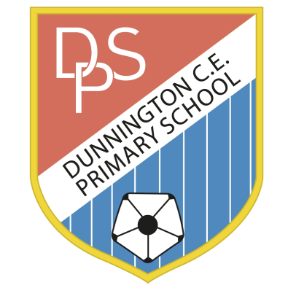 | DUNNINGTON C.E. PRIMARY SCHOOL  Pear Tree Lane  Dunnington  York YO19 5QG  Tel 01904 552910  dunnington.primary@york.gov.uk  www.dunningtonprimary.co.uk  Headteacher: Caroline Hancy  head.dunningtonprimary@york.gov.uk
Friday 18th September 2020
Dear Children and Parents/Carers,
On Friday 2nd October, Year 6 will be having a Victorian Day! We hope this will be a great way to learn more about our new topic, and experience History in a practical way.
Your child can come dressed as a Victorian school child for the day, with boys wearing shirts, shorts and possibly waistcoats, and girls wearing pinafores and dresses. You may even want to send your child to school with a traditional Victorian packed lunch!
In the Victorian times, children would often be expected to recite and rote learn things such as poetry, spellings and times table facts. We would like Year 6 to learn a verse from the poem ‘The Jabberwocky’ (please find attached) in preparation for Victorian Day. Learning more than one verse may impress your strict Victorian teacher!
We are looking forward to what will be a fun and memorable day!
Many thanks,
Miss Dickenson & Miss Dunn

The Jabberwocky by Lewis Carroll

’Twas brillig, and the slithy toves
Did gyre and gimble in the wabe:
All mimsy were the borogoves,
And the mome raths outgrabe.

“Beware the Jabberwock, my son!
The jaws that bite, the claws that catch!
Beware the Jubjub bird, and shun
The frumious Bandersnatch!”

He took his vorpal sword in hand;
Long time the manxome foe he sought—
So rested he by the Tumtum tree
And stood awhile in thought.

And, as in uffish thought he stood,
The Jabberwock, with eyes of flame,
Came whiffling through the tulgey wood,
And burbled as it came!

One, two! One, two! And through and through
The vorpal blade went snicker-snack!
He left it dead, and with its head
He went galumphing back.

“And hast thou slain the Jabberwock?
Come to my arms, my beamish boy!
O frabjous day! Callooh! Callay!”
He chortled in his joy.

’Twas brillig, and the slithy toves
Did gyre and gimble in the wabe:
All mimsy were the borogoves,
And the mome raths outgrabe.

