18th September 2020
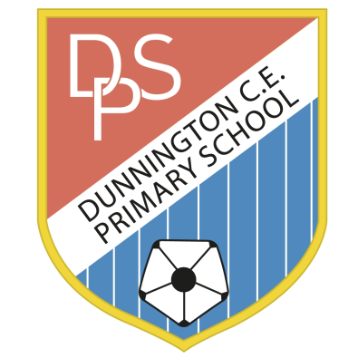 | DUNNINGTON C.E. PRIMARY SCHOOL  Pear Tree Lane  Dunnington  York YO19 5QG  Tel 01904 552910  dunnington.primary@york.gov.uk  www.dunningtonprimary.co.uk  Headteacher: Caroline Hancy  head.dunningtonprimary@york.gov.uk

Year 5 / 6 Curriculum Newsletter – Autumn Term 2020

Dear Parents/Carers,

Welcome back to the start of a new school year! The children have made such a positive start to their new classes and are adapting well to the changes in daily routines. Thank you for your on-going support with this. This year, Upper Key Stage 2 consists of three classes: two Year 6 classes and one Year 5. Mrs Lockwood is working in Year 5 as a Teaching Assistant and will be covering PPA time for all staff in Upper Key Stage 2.
Our Learning
A curriculum overview will be available on the website which outlines topics and areas of study for the year ahead. Additionally, every half-term there will be a Thematic Overview which breaks down the topic areas that we will be teaching. This term, the theme is ‘Victorians’ in Year 6 – this will be taught for the whole of the Autumn term. In Year 5, the topic is ‘Anglo Saxons’ (until October half-term) and then ‘Vikings’ which will be taught until Christmas. A Victorian Day has been planned for Year 6 which will take place on Friday 2nd October -please see the attached information.

You will be able to access curriculum overviews, copies of letters and information about events on the school website. We do share photographs and videos on our web page – if you have not already, please notify the school office if you do not want pictures or videos of your child to be used. In addition, activities in the classroom may sometimes involve children baking or eating so it is very important that you let us know at the start of the year if your child has any food allergies or if you do not want them to be involved in food tasting.

In Year 5 and 6 each child has their own locker near to their classroom which is for larger items such as coats, bags and PE kits. Occasionally, there may be impromptu PE activities or changes in the timetable so it is advisable to leave P.E. kits in school all week and take them home to wash at the weekend. The school PE kit consists of a ‘named’plain white T-shirt and black shorts (football kits are not appropriate for PE sessions). Trainers will be needed for outdoor PE and perhaps a tracksuit or black jogging bottoms for the colder months. A waterproof will be required for wet days as the children go out in all weathers and a spare pair of socks would be helpful to have in school at all times. Earrings must be removed for all PE sessions. If your child is unable to remove their earrings, please contact your child’s class teacher. Please notify us in writing or by e-mail in advance if your child is unable to participate in PE for any reason. We would like to thank you all for your support in ensuring that your child is well-equipped and organised for school this term; the children have approached their new class confidently and are settling in well.

Currently, PE sessions will take place at the following times:
Year 5 | Wednesday – Tennis | Friday - Fitness
Year 6 JD | Thursday - Netball | Monday - Fitness
Year 6 RD | Monday - Netball | Wednesday - Fitness

Homework
Year 6
Year 6 Homework | Set | Due in
Maths and English | Thursday | Tuesday (the following week)
Spellings | Monday | Friday

Monday: All children will be set a spelling task each week which relates to a particular spelling rule -this will include a list of spellings to practise at home. The children will be tested on their spelling list each Friday. At the moment, we are not sending workbooks home – your child will receive a hard copy.
Thursday: Maths and English homework will be set which is to be completed by the following Tuesday. All homework sheets will be placed on the website – a hard copy may be sent if requested. Please share all homework tasks on Seesaw so we can celebrate the homework in school.
Year 5
Year 5 Homework | Set | Due in
Maths, English, Topic or Science | Thursday | Tuesday (the following week)
Spellings | Spellings are sent at the beginning of each half term and  will be tested weekly on Fridays.

Reading
Our aim in school is to encourage a love of books and reading for enjoyment; therefore, children and staff will read every day in school. The children will share an on-going whole class text which will be a focus of most reading lessons. In addition, the children will read an independent reading book which can be brought to and from school each day. Any books borrowed from school must be placed in a box in the classroom on their return. The children are working hard to learn and understand a wide range of ‘new’ vocabulary that will support them in writing and in their understanding when approaching challenging texts. Please encourage your child to ask you if they are unsure of the meaning of a word or guide them towards a dictionary. The robbery books, which are being used in school, are a brilliant way of collecting new vocabulary.

Please email us as soon as possible if you have any concerns regarding your child, however trivial they may seem. We have included our e-mails for any non-urgent issues and we will endeavour to reply to these as soon as possible. Anyone needing a quick response should phone the school in the usual way.

We are looking forward to a fun-filled year of learning!

Yours sincerely,

The Year 5 and 6 team

Rachel Dickenson Rachel.Dickenson@Dunnington.yorkschools.net
Jessica Dunn Jessica.Dunn@Dunnington.yorkschools.net
Tracey Elliott Tracey.Elliott@Dunnington.yorkschools.net
Edwina Subritzky Edwina.Subritzky@Dunnington.yorkschools.net
Jenny Lockwood

