Task 1 – Create a piece of artwork to depict this scene.
Across the grove the branches parted and three beings stepped out from the trees. They were about Mallory’s size, with freckled skin browned by sunlight. The first was a woman with apple green eyes and a green sheen across her shoulders and at her temples. Leaves were tangled in her tousled hair. The second was a man with what looked like small horns along his brow. His skin was flushed a deeper green than the woman’s and he held a gnarled staff in his hands. The third elf had thick, red hair woven with red berries and two large seedpods that stuck up on either side of his head. His skin was brown, speckled with red at his throat.
“No one has followed this path for a long time,” said the green-eyed elf. She held her head high, like one accustomed to being obeyed.
The elves were beautiful, but the only emotion he could read on their faces was a strange hunger that unnerved Jared.
Then, a few branches untwined and something else stepped through.
It was white and the size of a deer. Its fur was ivory and its long mane hung in tangles. The horn that jutted from its forehead was twisted to an end that looked sharp. It lifted its wet nose and scented the air. As it approached them, the valley went quiet. Even the creature’s own steps were noiseless. It didn’t look at all tame.
Something began to surface behind her. At first it looked like a small hill rising from the water, stony and covered in moss. Then a head emerged, the deep green of rotten river grass, with small black eyes, a nose that was gnarled like a branch, and a mouth full of cracked teeth. A hand reached towards them. Its fingers were as long as roots, and its nails were black with murk. Jared breathed in the stench of the bottom of the pool, putrid leaves, and old, old mud.

Task 2
- Design either a common house brownie or a boggart.
Your design should be in the form of a non-chronological report (see features sheet). You must plan, draft, edit and redraft your work and then ask an adult to read it aloud. Ensure that you maintain the correct form throughout and that your work makes sense.
Remember: Brownies are fiercely loyal and will defend a home from burglars and goblins. Although they love their home being clean, they are rather shabby in appearance. If taken advantage of, they may become a boggart who take delight in tormenting those they had once protected!
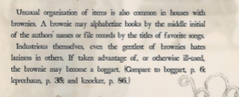
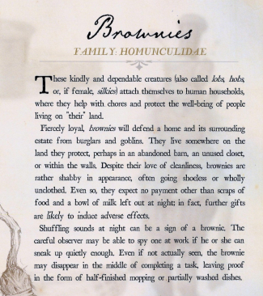
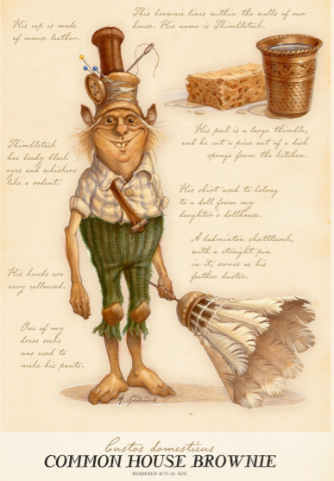
Design your creature carefully! Think about their roles in the household. Below are some ideas for your creature…Be creative!

