Four Triangles Puzzle
If you cut a square diagonally from corner to corner you get four right-angled isosceles triangles.

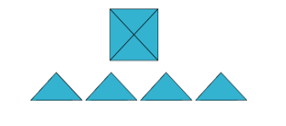

- How many different shapes can you make by fitting the four triangles back together?
You may only fit long sides to long sides and short sides to short sides.
The whole length of the side must be joined.

You might like to record what you do by using the worksheet provided.

