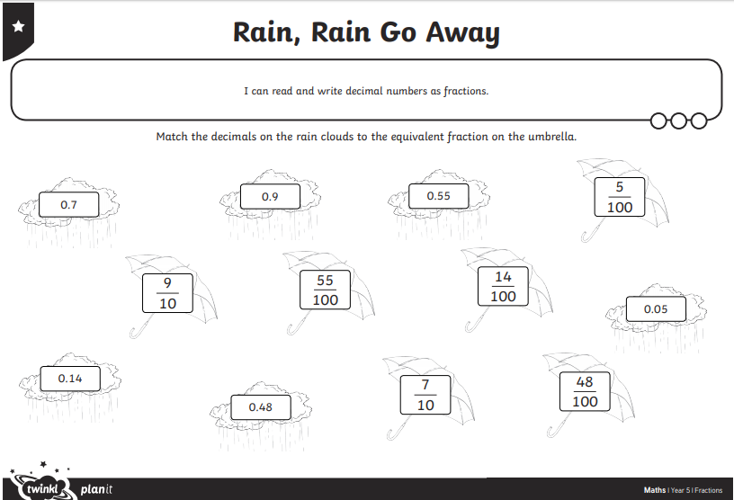
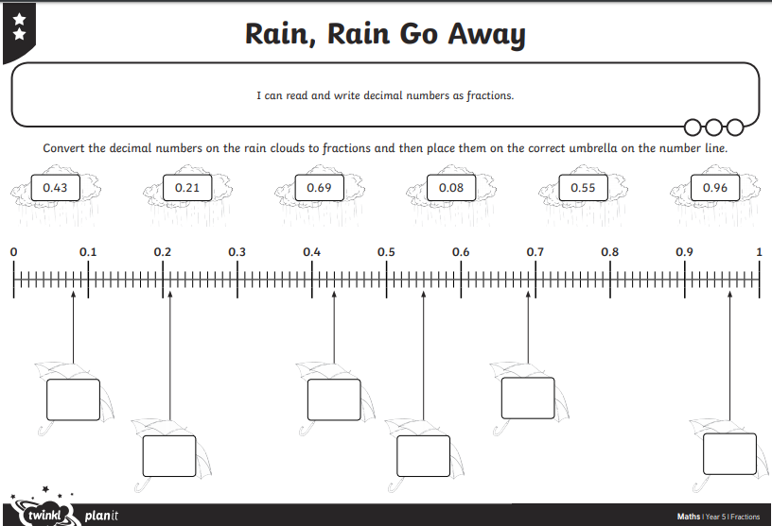
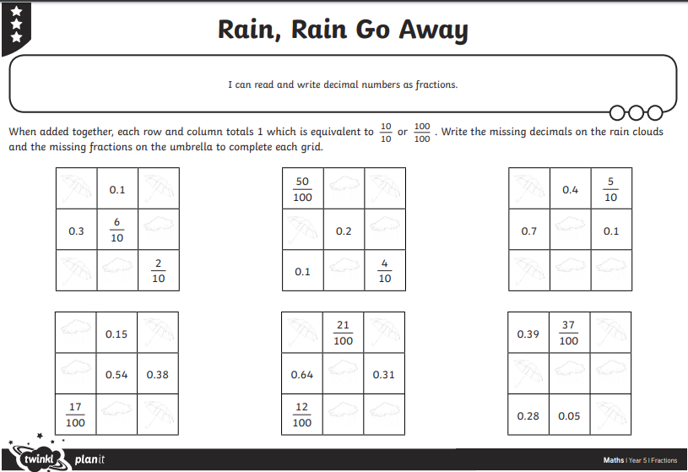
Fluency

- Write the equivalent decimals and fractions for these:

- 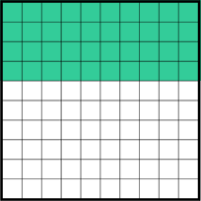

- 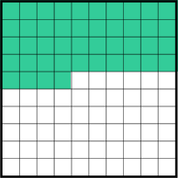

- 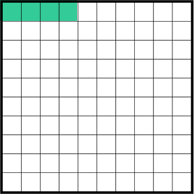

Fluency

- Write each value as a fraction and as a decimal

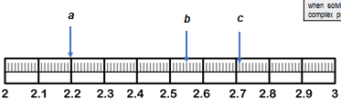

- Complete the table

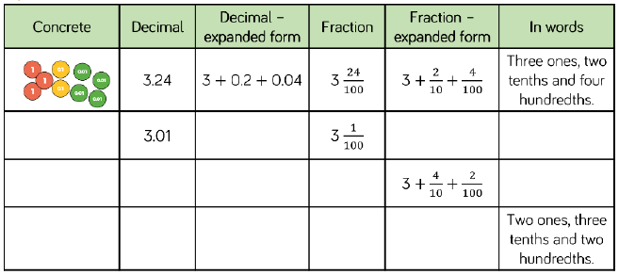

Reasoning and Problem Solving

- 2.25 = 2 ones, 2 tenths and 5 hundredths.
Can you write the following numbers in at least 3 different ways?

- Use these digit cards to complete the decimal in different ways. Write the possibilities down as decimals and fractions.
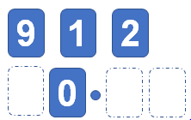
How many possibilities are there?

- Will Amir’s idea ALWAYS, SOMETIMES or NEVER work? Write two examples of converting fractions to prove your thinking

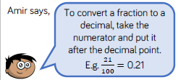

- True or False?

  - If a number has one decimal place, it can be written as a number of tenths
  - 2$\frac{7}{100}$ = 2.7
  - 4 is less than 26, so 0.4 is less than 0.26
  - 5$\frac{5}{10}$ = 5.50

