The Spiderwick Chronicles by Holly Black and Tony Diterlizzi

If you have been in school (WB 16th November) you will have completed some of the initial tasks. You can record the English tasks in your green book.
Task 1 | Read Chapters 1 and 2 – The Field Guide. Create an A4 information page about the three children Mallory, Simon and Jared). This should include the following:  - Titles, subheadings and captions  - Drawings  - Character descriptions with evidence from the text
Task 2 | Read Chapter 3 – Think about the riddle on p34…what does it imply?  - Create your own riddle!  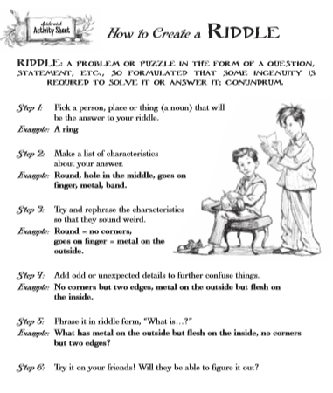
Task 3 | Read Chapters 4 and 5.
Task 4 | Read Chapter 6. Sketch the kitchen scene and write a description of the destruction encountered by Jared.  Who is responsible for the mess?  In your description, include the following vocabulary:  - Porcelain bowl  - Imprint  - Oozed  - Scattered  - Feathering
Task 5 | Read Chapter 7  Character Drawing (page 103)  There was a loud sound of a throat being cleared, and the three turned towards the desk. Standing on it, in worn overalls and a wide-brimmed hat, was a little man about the size of a pencil. His eyes were as black as beetles, his nose was large and red, and he looked very much like the illustration from the Guide. He was holding a pair of leashes that attached to two grey mice that were sniffing the edge of the desk.  - Create this character in your book
Task 6 | 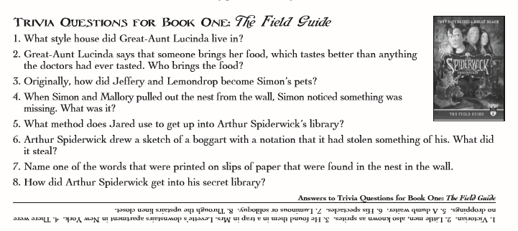  Answer the questions below and record in your green book. The answers are at the bottom! (Try not to look!)

