My Fact Sheet about Snails
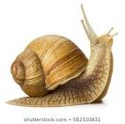
Draw | Draw
……………………………….  ……………………………….  ………………………………. | ……………………………….  ……………………………….  ……………………………….
Draw | Draw
………………………………..  ………………………………..  ……………………………….. | ………………………………..  ………………………………..  ………………………………..

