To evaluate relationships between characters

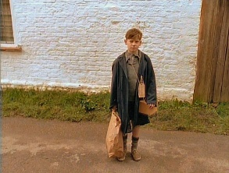
- Provide two examples that show Tom likes Willie. Use examples from the text to support your answers.
……………………………………………………………………………………………………………………………………………………………………………………………………………………………………………………………………………………………………………………………………………………………………………………………………………………………………………………………………………………………………………………………………………………
- Why has Willie changed Tom’s opinion on evacuees?
……………………………………………………………………………………………………………………………………………………………………………………………………………………………………………………………………………………………………………………………………………………………………………………………………………………………………………………………………………………………………………………………………………………
- Can you think of any qualities or experiences that these characters might have in common? Explain your answer.
……………………………………………………………………………………………………………………………………………………………………………………………………………………………………………………………………………………………………………………………………………………………………………………………………………………………………………………………………………………………………………………………………………………
- Predict how their relationship will develop. Which events in the text have helped you come to this conclusion?
……………………………………………………………………………………………………………………………………………………………………………………………………………………………………………………………………………………………………………………………………………………………………………………………………………………………………………………………………………………………………………………………………………………

