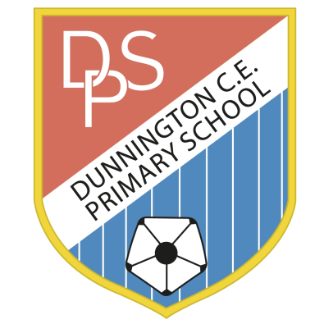 | DUNNINGTON C.E. PRIMARY SCHOOL  Pear Tree Lane  Dunnington  York YO19 5QG  Tel 01904 552910  dunnington.primary@york.gov.uk  www.dunningtonprimary.co.uk  Headteacher: Caroline Hancy  head.dunningtonprimary@york.gov.uk
Tuesday 14th September 2020
Dear Year 6 Children and Parents/Carers,
On Friday 1st October, Year 6 will be having a Victorian Day! I hope this will be a great way to learn more about our new topic, and experience History in a practical way.
Your child can come dressed as a Victorian school child for the day, with boys wearing shirts, shorts and possibly waistcoats, and girls wearing pinafores and dresses. You may even want to send your child to school with a traditional Victorian packed lunch!
I am looking forward to what will be a fun and memorable day!
Many thanks,
Miss Dickenson

