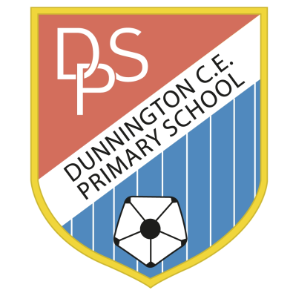 | DUNNINGTON C.E. PRIMARY SCHOOL  Pear Tree Lane  Dunnington  York YO19 5QG  Tel 01904 552910  dunnington.primary@york.gov.uk  www.dunningtonprimary.co.uk  Headteacher: Caroline Hancy  head.dunningtonprimary@york.gov.uk
14th September 2021

Year 5 / 6 Curriculum Newsletter – Autumn Term 2021

Dear Parents/Carers,

Welcome back to the start of a new school year! The children have made such a positive start to their new classes and are adapting well to the changes in daily routines. Thank you for your on-going support with this. This year, Upper Key Stage 2 consists of two classes: one Year 6 class and one Year 5. Mrs Lockwood is working as a Teaching Assistant and will be covering PPA time for all staff in Upper Key Stage 2.
Our Learning
A curriculum overview will be available soon on the website which outlines topics and areas of study for the year ahead. Additionally, every half-term there will be a Thematic Overview which breaks down the topic areas that we will be teaching. This term, the theme is ‘Victorians’ in Year 6 – this will be taught for the whole of the Autumn term. In Year 5, the topic is ‘Anglo Saxons’ (until October half-term) and then ‘Vikings’ which will be taught until Christmas. A Victorian Day has been planned for Year 6 which will take place on Friday 1st October -please see the attached information.

You will be able to access curriculum overviews, copies of letters and information about events on the school website. We do share photographs and videos on our web page – if you have not already, please notify the school office if you do not want pictures or videos of your child to be used. In addition, activities in the classroom may sometimes involve children baking or eating so it is very important that you let us know at the start of the year if your child has any food allergies or if you do not want them to be involved in food tasting.

In Year 5 and 6 each child has their own locker near to their classroom which is for larger items such as coats, bags and PE kits. Occasionally, there may be impromptu PE activities or changes in the timetable so it is advisable to leave P.E. kits in school all week and take them home to wash at the weekend. The school PE kit consists of a ‘named’ plain white T-shirt and black shorts (football kits are not appropriate for PE sessions). Trainers will be needed for outdoor PE and perhaps a tracksuit or black jogging bottoms for the colder months. A waterproof will be required for wet days as the children go out in all weathers and a spare pair of socks would be helpful to have in school at all times. Earrings must be removed for all PE sessions. If your child is unable to remove their earrings, please contact your child’s class teacher. Please notify us in writing or by e-mail in advance if your child is unable to participate in PE for any reason. We would like to thank you all for your support in ensuring that your child is well-equipped and organised for school this term; the children have approached their new class confidently and are settling in well.

PE sessions will take place at the following times:

Year 5 | Monday and Thursday
Year 6 | Monday and Wednesday

Homework

Homework | Set | Due in
Maths, English, Topic or Science | Thursday | Tuesday (the following week)
Spellings | Monday | Friday

Monday: In Year 6, all children will be set a spelling homework task each week which relates
to a particular spelling rule -this will include a list of spellings to practise at home. The children
will be tested on their spelling list each Friday. Spelling tasks will be set on Google Classroom
at the beginning of the week - work should be submitted by the following Friday. In Year 5,
spellings are sent at the beginning of each half term and will be tested weekly on Fridays.

Thursday: Maths and English homework will be set each week which is to be completed by the following Tuesday. All homework tasks will be set on a Google Classroom with worksheets being sent home as a hard copy when appropriate. A red homework book will be sent home too as another option for recording work.

Reading
Our aim in school is to encourage a love of books and reading for enjoyment; therefore, children and staff will read every day in school. The children will share an on-going whole class text which will be a focus of some reading lessons. In addition, the children will read an independent reading book which can be brought to and from school each day. Your child will also be provided with a reading record, to provide an indication of their reading progress. We ask that children bring their reading record in between home and school, to help keep a regular record, and encourage them to read and make comments about books on completion. Please feel free to write any comments you may have in your child’s reading record. The children are working hard to learn and understand a wide range of ‘new’ vocabulary that will support them in writing and in their understanding when approaching challenging texts. Please encourage your child to ask you if they are unsure of the meaning of a word or guide them towards a dictionary. The robbery books, which are being used in school, are a brilliant way of collecting new vocabulary.

Please email us as soon as possible if you have any concerns regarding your child, however trivial they may seem. We have included our e-mails for any non-urgent issues and we will endeavour to reply to these as soon as possible. Anyone needing a quick response should phone the school in the usual way.

We are looking forward to a fun-filled year of learning!

Yours sincerely,

The Year 5 and 6 team

Rachel Dickenson Rachel.Dickenson@Dunnington.yorkschools.net
Jessica Dunn Jessica.Dunn@Dunnington.yorkschools.net
Jenny Lockwood

