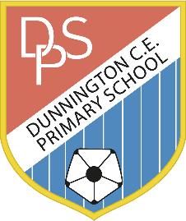KS1 Enrichment Activities Topic: “Florence Nightingale‘’



|  |  |
| --- | --- |
| **Activities I have chosen** | **Homework Activity Choices** |
|  | Use any of the following websites to practice an area of math’s you would like to get better at:  <http://www.conkermaths.org/cmweb.nsf/pages/kirfs.html> <http://www.bbc.co.uk/bitesize/ks1/maths/> <http://www.ictgames.com/>  Year 1 - <https://www.topmarks.co.uk/maths-games/hit-the-button>- practice your 2x tables  and if you want a challenge move onto 5x and 10x tables. |
|  | Create your own word problems using addition and subtraction. This can be done with pictures or words. E.g. I had 18 apples and gave six away. How many apples are left? |
|  | Can you bring in a recipe for a cake or cup cakes with the weight of each ingredient? Feel free to make them at home! |
|  | Write a diary about a weekend. Yr 1: Make sure all of your sentences have capital letters and full stops. Yr 2: How many different types of punctuation can you include? |
|  | Read a book and find out the meaning of three words you don’t understand. Tell your class  about the three new words. |
|  | Write a story of your own choice. Remember to pick a character, setting, problem and resolution. Use your wild imaginations to impress us! |
|  | Set yourself a sporting challenge (running, jumping, skipping, hopping). How many times can you do this in one minute? Can you beat your personal best? |
|  | Create a picture of a family member in the media of your choice trying to make sure the length of arms and legs is correct. Write a caption underneath. |
|  | Keep a weather diary for 5 days. Each day try to look at the type of weather it is, the temperature, how the weather changes or doesn’t during the day and anything else you notice. |
|  | Practise learning the names of the Continents and oceans. Here’s a game and two songs.  <https://world-geography-> [games.com/world.html](https://world-geography-games.com/world.html)  <https://www.youtube.com/watch?v=K6DSMZ8b3LE>  https://www.youtube.com/watch?v=K6DSMZ8b3LE |

Maths activity Literacy activity Topic activity

Parent Feedback

How did your child get on?